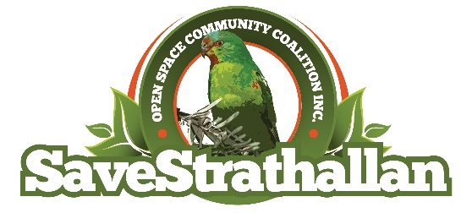
Save Strathallan Open Space Community Coalition Inc.
100 Main Drive, BUNDOORA, VIC 3083

Newsletter 3 March 2018

Status of Sale of Strathallan Open Space

It has been quite some time since we have published a newsletter. There has been a lot of activity, but we have not yet achieved our objective – to maintain the current zoning and usage of the Strathallan Open Space. This objective will not be achieved if La Trobe University continues to “own” this land.

We have had great support from Colin Brooks the MLA for Bundoora, Banyule and Darebin City Councils. The Mayor of Darebin has recently reiterated the Council’s 100% support for our campaign.

During August 2017, two articles appeared in the Preston Leader. The initial article indicated the University’s plan to utilise the land for residential & recreational purposes. The latter article indicated that La Trobe was prepared to sell the land to Darebin City Council to facilitate the retention of the land as “Open Space”.However, at this point the negotiations between the Council and La Trobe are still ongoing. It appears to us the sticking point is the price expected by the University. The Preston Leader reported in October 2017 that La Trobe are expecting $25million, based on a valuation by the Victorian Valuer General. However, the detail of that valuation has been kept confidential. We believe this price is outrageous. The SSOSCC has written to the Valuer General asking for a review, based upon a number of factors, including an independent valuation commissioned by the Strathallan Golf Club. This very professional report valued the land at $1.5 million; and the Darebin Council rate valuation is $2.1 million.
We are waiting for a response from The Valuer General.

Batman by-election

Voters in the Federal electorate of Batman go to the polls on Saturday 17 March to elect a replacement for David Feeney.

The Strathallan Open space is considered one of the most critical environmental issues in the Batman electorate.

Owen Macdonald, a local resident and committee member of the SSOSCC has written a letter to each registered candidate for the by-election. Below is a summary of the responses Owen has received.

 | Candidate responses to Owen Macdonald
1 | GENTLE, Yvonne | Rise Up Australia Party
2 | KEARNEY, Ged | Australian Labor Party | The response is non-committal
3 | BHATHAL, Alex | The Greens | Yes, does support local community
4 | BAILEY, Kevin Christopher | Australian Conservatives | Yes, does support local community
5 | BURNS, Tegan | Australian People's Party | Yes, does support local community
6 | ROBINSON, Debbie | Australian Liberty Alliance | Yes, does support local community
7 | VAN LIESHOUT, Teresa | Independent | Yes, does support local community
8 | WHITEHEAD, Adrian |  | Yes, does support local community
9 | MCDONALD, Mark | Sustainable Australia | Yes, does support local community
10 | SMITH, Miranda Joyce | Animal Justice Party

We encourage all eligible voters in the by-election to contact candidates and continue to draw attention to the issue.

Regards Peter Roberts-President

